Optimal tracking of the water level for a coupled tank system using Linear Quadratic Regulator
Pedro Teppa-Garran
pteppa@unimet.edu.ve
Universidad Metropolitana, Caracas, Venezuela

Abstract
It is proposed an optimal controller that will lead to zero asymptotic steady-state tracking error. The reference inputs can include steps, ramps, and other persistent signals. For a step signal, it is well known that zero steady- state tracking error can be achieved with a type-one open loop system. This idea is formalized in this work, by augmenting the coupled tank system model with an internal model of the reference input. Then, through the Linear Quadratic Regulator (LQR) method, the desired performance objectives are addressed by minimizing a quadratic function of the state and control input. Experimental results on the coupled tank system have been provided to illustrate the effectiveness of the method.
Keywords: Reference tracking, Optimal control, LQR, Internal model, Coupled tank system.

Seguimiento óptimo del nivel de agua de un sistema de tanques acoplados empleando el regulador lineal cuadrático
Resumen
Se propone un controlador óptimo que resultará en un error de seguimiento asintótico en estado estacionario nulo. Las entradas de referencia pueden incluir escalones, rampas y otras señales persistentes. Para una señal tipo escalón, es bien conocido que se puede lograr un error de seguimiento de estado estacionario cero con un sistema de lazo abierto de tipo uno. Esta idea se formaliza en este trabajo, aumentando el modelo del sistema de tanques acoplados con un modelo interno de la entrada de referencia. Luego, a través del regulador lineal cuadrático (LQR, por sus siglas en inglés), los requerimientos de diseño sobre la respuesta temporal son incorporados mediante la minimización de una función cuadrática dependiente de las variables de estado y de la señal de control. Se proporcionan resultados experimentales en el sistema de tanques acoplados para ilustrar la efectividad del método.
Palabras clave: Seguimiento de señales de referencia, Control óptimo, LQR, Modelo interno, Sistema de tanques acoplados.

Suivi optimal du niveau d'eau pour un système de réservoirs couplés utilisant le régulateur quadratique linéaire
Resumé
Il est proposé un contrôleur optimal qui produira une erreur de poursuite nulle en régime permanent asymptotique. Les entrées de consigne peuvent inclure des échelons, des rampes et d'autres signaux persistants. Pour un signal type échelon, il est bien connu qu'une erreur de poursuite en régime permanent nulle peut être obtenue avec un système à boucle ouverte de type un. Cette idée est formalisée dans ce travail, en augmentant le modèle du système de réservoirs couplés avec un modèle interne de l'entrée de référence. Ensuite, grâce au régulateur quadratique linéaire (LQR, pour son sigle en anglais), les objectifs de performance souhaités sont atteints en minimisant une fonction quadratique de l'état et de l'entrée de commande. Des résultats expérimentaux sur le système de réservoirs couplés ont été fournis pour illustrer l'efficacité de la méthode.
Mots clés: Suivi de référence, Commande optimale, LQR, Modèle interne, Système de réservoirs couplés.

Rastreamento ideal do nível de água para um sistema de tanque acoplado usando regulador quadrático linear
Resumo
É proposto um controlador ótimo que levará a zero erro de rastreamento assintótico em estado estacionário. As entradas de referência podem incluir degraus, rampas e outros sinais persistentes. Para um sinal de passo, é bem conhecido que o erro de rastreamento em estado estacionário zero pode ser alcançado com um sistema de malha aberta tipo um. Esta ideia é formalizada neste trabalho, aumentando o modelo do sistema de tanque acoplado com um modelo interno da entrada de referência. Em seguida, por meio do método do Regulador Quadrático Linear (LQR, por sua sigla em inglês), os objetivos de desempenho desejados são abordados minimizando uma função quadrática do estado e da entrada de controle. Resultados experimentais no sistema de tanque acoplado foram fornecidos para ilustrar a eficácia do método.
Palavras-chave: Rastreamento de referência, controle ideal, LQR, modelo interno, sistema de tanque acoplado

- INTRODUCCIÓN
Technologies such as chemical reactors, fermentation vessels, and steam and surge drums benefit from accurate level instrumentation and control [1, 2, 3, 4]. Tank level control systems are used frequently in different processes. For example: pharmaceutical industries, petrochemical plants, food/beverages industries and nuclear plants; depend upon tank level control systems. Often the tanks are coupled, so there is interaction between their levels, resulting in a nonlinear behavior and may also exhibit non minimum phase characteristics [5, 6].
There are numerous control policies developed for coupled tank systems. Among them, we can mention: Proportional-Integral-Derivative (PID) type controllers [7, 8, 9], Fuzzy control [10, 11], Model
Predictive Control [12, 13], Backstepping Control
[14, 15], Sliding-Mode Control [16, 17], Fractional
PID type controllers [18, 19], Robust control [20] and Active Disturbance Rejection Control [21].
In this work, it is used Linear Quadratic Regulator Optimal Control (LQR) [22, 23]. This method is well known in modern optimal control theory and has been widely used in many applications [22]. LQR design has already been employed to control the liquid level of the tank system [24, 25, 26]. The relevance of this work aims to focus on determining an optimal solution by using the LQR method to the tank system tracking problem. Specially, it is desired to find asymptotic optimal tracking with zero steady-state error. This is formalized by introducing an internal model of the reference input [27, 28] in the state feedback control law previously obtained from a LQR problem.
The article is organized as follows. Section II describes the coupled tank system. In section III, the internal model principle and optimal LQR design are used to formulate a method that guarantees zero steady-state tracking error for the water level. Finally, in section IV, it is shown the effectiveness of the optimal design through its application to the coupled tank system and Conclusions.
- COUPLED TANK SYSTEM
The coupled tank system is given in Fig. 1. The setup experiment also includes a personal computer and the Matlab/Simulink software interface. The apparatus is used in the control laboratory at the Simón Bolívar University in
PEDRO TEPPA-GARRAN

Venezuela. It consists of a single pump with two tanks. Each tank is instrumented with a pressure sensor to measure the water level. The pump drives the water from the bottom basin up to the top of the system. Depending on how the outflow valves are configured, the water then flows to the top tank, bottom tank or both. One configuration is shown in Fig. 2, where the output of the pump is connected to the first tank.
The nonlinear state space model [6, 29] is shown in
(1) where the state vector is equal to the tanks levels, the control signal corresponds to the input voltage applied to the pump and the output is chosen as the second tank level.

−𝐶₁  𝖥 𝐴 �𝑥₁(𝑡) 0 ⎤  𝒙̇ (𝑡) = ⎢ 1 ⎥ 𝒙(𝑡)  ⎢ 𝐶1 �𝑥 (𝑡) −𝐶2 �𝑥 (𝑡)⎥  ⎣ 𝐴₂ ¹ 𝐴₂ ² ⎦  + �𝐾𝑝⁄𝐴1� 𝑢(𝑡)  0  𝑦(𝑡) = [0 1]𝒙(𝑡) | (1)

With 𝐶₁ = 𝐴_{𝑑1}�2𝑔, 𝐶₂ = 𝐴_{𝑑2}�2𝑔, 𝐴₁ and 𝐴₂ denote the cross-sectional area of the tanks 1 and 2, respectively. 𝐴_{𝑑1}, 𝐴_{𝑑2} give the cross-sectional areas of the corresponding orifices, 𝑔 is the gravitational constant on Earth and 𝐾_{𝑝} is the pump flow constant.
The nonlinear model is linearize in the operating point [𝐿�1, 𝐿�2]^{𝑇}resulting in the equations

−𝐶1 0  𝒙̇ (𝑡) = �^{2𝐴1}�𝐿�1 � 𝒙(𝑡) + �𝐾𝑝⁄𝐴1� 𝑢(𝑡)  𝐶1 −𝐶2 0  2𝐴2�𝐿�1 2𝐴2�𝐿�2  𝑦(𝑡) = [0 1]𝒙(𝑡) | (2)
The description and numerical values of the physical parameters for the tank system are given in Table 1.
By employing the numerical values from Table 1. It is possible to perform the following calculations
𝐴₁ = 𝐴₂ = 𝜋(4.445⁄2)² = 15.53 𝑐𝑚²
𝐴_{𝑑1} = 𝜋(0.635⁄2)² = 0.317 𝑐𝑚²
𝐴_{𝑑2} = 𝜋(0.476⁄2)² = 0.178 𝑐𝑚²
𝐿�1 = 𝐿�2 = 15 𝑐𝑚
Replacing the previous values in (2) allows to obtain the linear model of the coupled tank system as

where
𝒙̇ (𝑡) = 𝑨𝒙(𝑡) + 𝑩𝑢(𝑡)  𝑦(𝑡) = 𝑪𝒙(𝑡) | (3)

𝑨 = �−𝑎 0

𝑐 [ ]
PEDRO TEPPA-GARRAN

input 𝑦_{𝑟}(𝑡) = 𝑟 with zero steady-state error 𝑒(𝑡)
defined as

𝑒(𝑡) = 𝑦_{𝑟}(𝑡) − 𝑦(𝑡) | (4)
Taking the time-derivative of the auxiliary signal

𝑎 −𝑏� , 𝑩 = �0� , 𝑪 = 0 1
With 𝑎 = 0.1168, 𝑏 = 0.0656 and 𝑐 = 0.2577.
Table I. Physical parameters of the coupled tank system.
𝜀(𝑡) = −𝑒(𝑡) and using the output equation in (3) yields
𝜀̇(𝑡) = 𝑦̇(𝑡) − 𝑟̇ = 𝑪𝑥̇(𝑡) − 0 = 𝑪𝑥̇(𝑡)

Applying now, time-derivative to the state equation in (3) and defining the intermediate variables
Description | Value | Unit
Pump flow constant | 4 | 𝑐𝑚³/𝑠/𝑉
Out 1 Orifice Diameter | 0.635 | 𝑐𝑚
Out 2 Orifice Diameter | 0.476 | 𝑐𝑚
Tanks Diameter | 4.445 | 𝑐𝑚
Tanks Height | 30 | 𝑐𝑚
Gravitational constant on Earth | 981 | 𝑐𝑚⁄𝑠²
Maximum flow | 100 | 𝑐𝑚³⁄𝑠
Pump peak voltage | 22 | 𝑉

𝒗(𝑡) = 𝒙̇ (𝑡) and 𝑢₀(𝑡) = 𝑢̇ (𝑡) leads to the step tracking system

�𝜀̇(𝑡)� = �0 𝑪� �𝜀(𝑡)� + �0� 𝑢₀(𝑡)  𝒗̇ (𝑡) 0 𝑨 𝒗(𝑡) 𝑩 | (5)
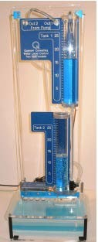
Or equivalently, in compact form
𝒛̇(𝑡) = 𝑨_{𝒂}𝒛(𝑡) + 𝑩_{𝒂}𝑢₀(𝑡) | (6)
for the vector 𝒛(𝑡) = [𝜀(𝑡) 𝒗(𝑡)]^{𝑇} and augmented matrices
𝑨_{𝒂} = �0 𝑪� , 𝑩_{𝒂} = � 0�
0 𝑨 𝑩
In order to have a LQR formulation of the tracking problem, the following quadratic cost is considered
∞  𝐽 = � [𝒛(𝑡)^{𝑇}𝑸𝒛(𝑡) + 𝜌𝑢₀(𝑡)²] 𝑑𝑡  0 | (7)

Figure 1. Coupled tank system.

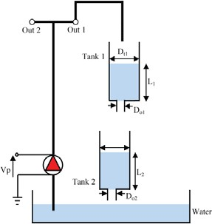
where 𝑸 is a positive semi-definite matrix which has an impact on the closed-loop transient response and parameter 𝜌 > 0 can be used to tune the amplitude of the control signal. It is well known [22, 23] that the state feedback control

𝑢₀(𝑡) = −𝑲𝒛(𝑡) | (8)
minimizes Eq. (7) and stabilizes system (6) with the vector 𝑲 equal to
𝑲 = −𝜌⁻¹𝑩_{𝒂}^{𝑇}𝑷 | (9)
Here 𝑷 is the symmetric positive definite solution of the Continous Algebraic Riccati Equation given by

𝑨_{𝒂}^{𝑇}𝑷 + 𝑷𝑨_{𝒂} − 𝜌⁻¹𝑷𝑩_{𝒂}𝑩_{𝒂}^{𝑇}𝑷 + 𝑸 = 𝟎 | (10)
Since, it can be easily verified that the system (5) with matrices 𝑨, 𝑩 and 𝑪 from (3) is controllable [30]. We can find constants 𝐾₁ and 𝑲₂ by expressing gain vector 𝑲 ∈ ℝ^{1𝑥(𝑛+1)} as 𝑲 =

Figure 2. Standard configuration of the coupled tank system.
- OPTIMAL TRACKING CONTROL SYSTEM
� 𝐾�₁
1𝑥1
𝑲�𝟐 � in (8). The resulting equation is
1𝑥𝑛
𝑢₀(𝑡) = −[𝐾₁ 𝑲_{𝟐}] �𝜀(𝑡)�  𝑣(𝑡) | (11)

DESIGN
We begin by considering the design problem to enable the optimal tracking of a step reference
After performing time-integration in (11), the control signal 𝑢(𝑡) in (3) applied to the coupled tank system is

PEDRO TEPPA-GARRAN

𝑡  𝑢(𝑡) = 𝐾₁ � 𝑒(𝑟) 𝑑𝑟 − 𝑲₂𝒙(𝑡)  0 | (12)
Equation (12) guarantees system (6) is stable and the quadratic cost (7) is minimized. The above results are summarized in Theorem 1 and the corresponding control system block diagram in Fig. 3
Theorem 1: If the state feedback control law (12) is applied to the coupled tank system. The error signal
(4) for a step reference input 𝑦_{𝑟}(𝑡) = 𝑟 will tend asymptotically to zero minimizing the quadratic cost
(7) for a given positive semi-definite matrix 𝑸 and parameter 𝜌 > 0.
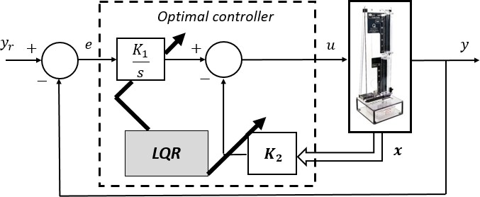
Figure 3. Optimal LQR internal model design for the coupled tank system for a step reference input.
It is straightforward to extend the method for a ramp reference input 𝑦_{𝑟}(𝑡) = 𝑡, 𝑡 ≥ 0. Taking twice the time-derivative of 𝜀(𝑡) = −𝑒(𝑡) and using (3) yields
𝜀(̈ 𝑡) = 𝑦̈(𝑡) − 𝑦_{𝑟}̈ (𝑡) = 𝑪𝒙̈ (𝑡) − 0 = 𝑪𝒙̈ (𝑡)
Defining the intermediate variables 𝒗(𝑡) = 𝒙̈ (𝑡) and
𝑢₀(𝑡) = 𝑢̈ (𝑡) gives

𝜀̇(𝑡) 0 1 0 𝜀(𝑡) 0  �𝜀(̈ 𝑡)� = �0 0 𝑪� �𝜀̇(𝑡)� + �0� 𝑢₀(𝑡)  𝒗̇ (𝑡) 0 0 𝑨 𝒗(𝑡) 𝑩 | (13)
Again, the previous equation can be expressed in the compact form given by (6) if the following augmented matrices are defined
0 1 0 0
𝑨_{𝒂} = �0 0 𝑪� , 𝑩_{𝒂} = �0 �
0 0 𝑨 𝑩
Since, system (13) with matrices 𝑨, 𝑩 and 𝑪 from
(3) is controllable [30]. We can compute constants
𝐾₁, 𝐾₂ and 𝑲₃ in (8) to form

𝑢₀(𝑡) = −𝐾₁𝜀(𝑡) − 𝐾₂𝜀̇(𝑡) − 𝑲₃𝒙̈ (𝑡) | (14)
The control signal 𝑢(𝑡) applied to the coupled tanks system is found by integrating (14) twice, this signal will cause the error signal (4), for a ramp reference input, tend asymptotically to zero minimizing the
quadratic cost (7) for a given positive semi-definite matrix 𝑸 and parameter 𝜌 > 0. Fig. 4 shows the block diagram of the control system.
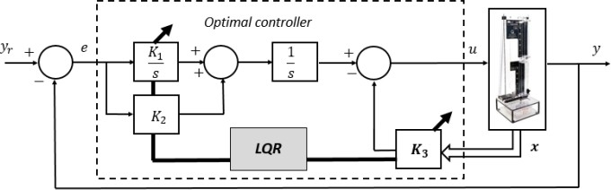
Figure 4. Optimal LQR internal model design for the coupled tank system for a ramp reference input.
- DESIGN TESTS ON A LABORATORY SETUP
The design technique is demonstrated through the implementation on the coupled tank system in real time and the corresponding results are presented in this section.
- Step reference input
The reference input applied to the coupled tank system is shown in Fig. (5). It consists of two changes in the set point, the first at 60 𝑠 and the second at 160 𝑠, after the start of the experiment.
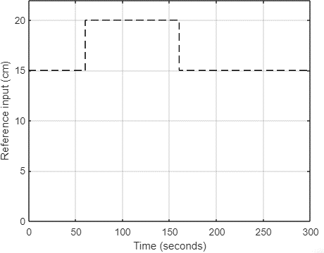
Figure 5. Input reference signal to validate the optimal controller design with step-like internal model.
Table 2 collects several experiments carried out to study the impact of the selection of matrix 𝑸 and the constant 𝜌 in (7) on the closed-loop performance of the system. The performance measures considered are: rise time (𝑡_{𝑟}), maximum percentage overshoot �%𝑀_{𝑝}�, integral square error (𝐼𝑆𝐸) and root mean square of the control signal (𝑢_{𝑅𝑀𝑆}) [31].
Gain 𝑲 in (8) is computed using the lqr function of Matlab. The syntax of the command is 𝑲 =
𝑙𝑞𝑟(𝑨_{𝒂}, 𝑩_{𝒂}, 𝑸, 𝜌). Experiments 1 to 4 show the influence of the constant 𝜌 in (7) on the amplitude

of the control signal applied to the coupled tank system. This is confirmed by the decrease in the value of 𝑢_{𝑅𝑀𝑆} as 𝜌 increases. Although the energy of the control effort decreases, on the other hand, the transient response tends to deteriorate slightly. The remaining experiments evaluate the contribution of the matrix 𝑸 in the transient response of the liquid level of the tank. The increase in the values of the diagonal of the matrix generates a faster system response at the expense of a greater overshoot. The time responses of the seven experiments of Table 2, from a practical point of view, are satisfactory. In order not to overload the article with an excessive amount of graphics, we select the first experiment to display some results. Figure 6 confirms the good tracking of the liquid level in the tank and Fig. 7 shows the control signal applied to the pump of the tank always within the voltage technological limits of the pump.
- Ramp reference input
The reference input applied to the coupled tank system is shown in Fig. 8.The seven experiments carried out to evaluate the ramp internal model and LQR design are summarized in Table 3. Each controller designed exhibits excellent results. In this case, we choose the response of the seventh experiment to display the performance of the control system, through figures 9 and 10.
Table II. Different experiments implemented on the coupled tank system to validate the optimal design of the controller for a step- type internal model in the reference input.

# | 𝑸, 𝝆 | 𝒕_{𝒓} | %𝑴_{𝒑} | 𝑰𝑺𝑬 | 𝒖𝑹𝑴𝑺
1 | 𝑸 = 𝑰, 𝜌 = 0.5 | 23.70 | 4.53 | 1411 | 6.59
2 | 𝑸 = 𝑰, 𝜌 = 1 | 28.44 | 5.13 | 1541 | 5.64
3 | 𝑸 = 𝑰, 𝜌 = 2 | 30.81 | 5.53 | 1709 | 5.54
4 | 𝑸 = 𝑰, 𝜌 = 4 | 38.71 | 5.80 | 1912 | 5.50
5 | 𝑸 = 5𝑰, 𝜌 = 1 | 17.38 | 8.13 | 1308 | 6.59
6 | 𝑸 = 10𝑰, 𝜌 = 1 | 11.85 | 14.00 | 1291 | 6.62
7 | 𝑸 = 20𝑰, 𝜌 = 1 | 11.06 | 21.53 | 1354 | 6.76

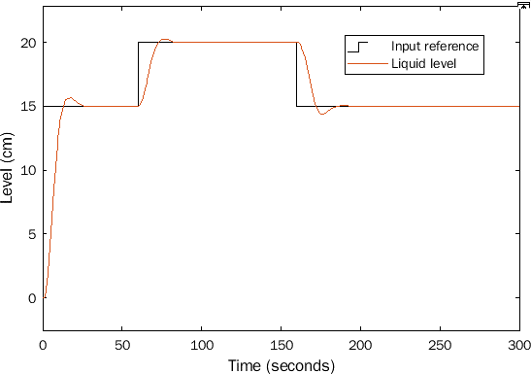
Figure 6. Closed-loop liquid level response for experiment 1 of Table: 2.

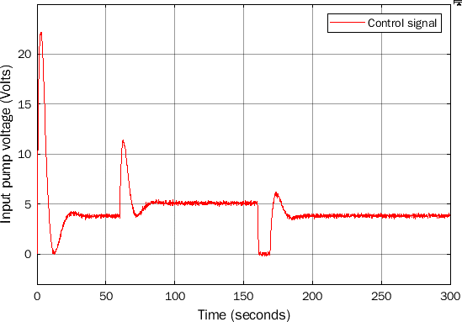
Figure 7. Control signal for experiment 1 of Table 2.
- Disturbance rejection
The disturbance rejection ability of the design from the experiment 1 of the step reference case is now studied through the following experiment. The system starts in the configuration of Fig. 2, but at
𝑡 = 100 𝑠 switches to that of Fig. 11, where the pump output feeds both tank 1 and tank 2 and at
𝑡 = 200 𝑠, it returns to the initial interconnection. This experiment allows to model a trapezoidal perturbation that operates in the interval [100; 200] 𝑠, causing a decrease in the inlet flow to tank 1 and the appearance of a direct flow in tank 2. Figure 12 shows the very satisfactory property of disturbance rejection achieved with the design method.

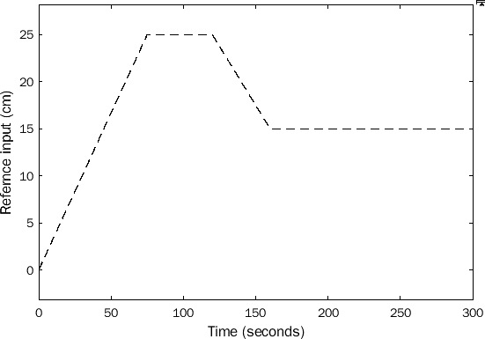
Figure 8. Input reference signal to validate the optimal controller design with ramp-like internal model.

Table III. Different experiments implemented on the coupled tank system to validate the optimal design of the controller for a ramp-type internal model in the reference input.

# | 𝑸, 𝝆 | %𝑴_{𝒑} | 𝑰𝑺𝑬 | 𝒖𝑹𝑴𝑺
1 | 𝑸 = 𝑰, 𝜌 = 0.5 | 4.00 | 15.5 | 4.74
2 | 𝑸 = 𝑰, 𝜌 = 1 | 4.32 | 19.7 | 4.74
3 | 𝑸 = 𝑰, 𝜌 = 2 | 4.68 | 25.1 | 4.73
4 | 𝑸 = 𝑰, 𝜌 = 4 | 5.10 | 32.6 | 4.72
5 | 𝑸 = 5𝑰, 𝜌 = 1 | 3.60 | 11.5 | 4.74

6 | 𝑸 = 10𝑰, 𝜌 = 1 | 3.32 | 9.5 | 4.74
7 | 𝑸 = 20𝑰, 𝜌 = 1 | 3.08 | 7.8 | 4.74

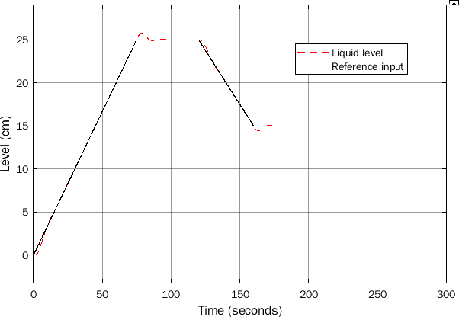
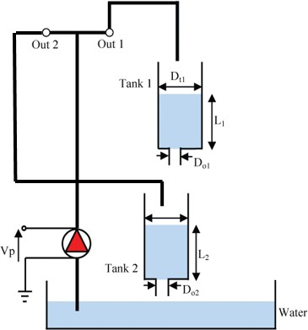
Figure 9. Closed-loop liquid level response for experiment 7 of Table 3.

- CONCLUSIONS
It is proposed a method to design a controller that guarantees the optimal tracking of the water level in a coupled tank system. The major advantage of the proposed design is the framework on which it is based, the combination of the internal model principle and the LQR optimal method, provides simplicity and flexibility in tuning the small number of controller gain parameters that are necessary for the implementation of the method. The experiments are performed on the coupled tank system and the results illustrate the effectiveness of the method.
Currently, research is being carried out on how to transfer specifications of the desired closed-loop transient response, for example, over shoot and settling time, in elements of the 𝑸 matrix of the quadratic cost of the LQR technique.

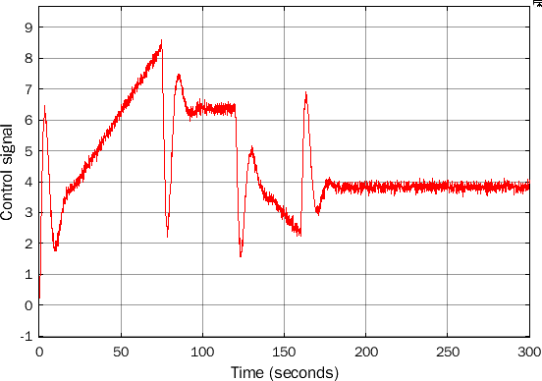
Figure 10. Control signal for experiment 7 of Table 3.
Figure 11. Connection scheme of the coupled tanks system to create a disturbance that decrease the inlet to tank 1.

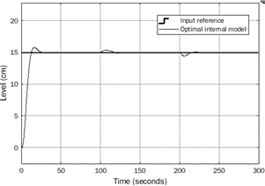
Figure 12. Closed-loop liquid level response for disturbance rejection.

ACKNOWLEDGMENTS
The author is grateful for the support provided by the Research Program of the Metropolitan University in Caracas, Venezuela through project number PG-A-14- 21-22.

REFERENCES

- Luyben, W. L. (1990) Process modeling, simulation and control for chemical engineers, (2nd ed.) New York, McGraw-Hill.
- Luyben, W.L. (2007) Chemical reactors design and control, AICHE, New York, Wiley.
- Rodrigues, R., J. Emi, A. Frattini & F. Vasconcelos (2013) A fuzzy-split range control system applied to a fermentation process, Bioresource Technology, vol. 142, pp. 475-482.
- Chakraborty,S., N. Manna & S. Dey (2014). Importance of three-elements boiler drum level control and its installation in power plant. International Journal of Instrumentation and Control Systems, vol. 4, no 2, pp. 1-12.
- Johansson. K. H. (2000) The quadruple-tank process: a multivariable laboratory process with an adjustable zero, IEEE Transaction Control System Technologies, vol.8, no 3, pp. 456-465.
- Grygiel, R., R. Bieda & M. Blachuta (2016) On significance of second-order dynamics for coupled tanks systems, Proc. of 21st International Conference on Methods and Models in Automation and Robotics, Poland.
- Singh, S., N. Katal & S. Modani (2014) Multi-objective optimization of PID controller for coupled-tank liquid- level system using genetic algorithm, Advances in Intelligent Systems and Computing, vol. 236, pp. 59-66.
- Mute, D., S. Mahapatro & K. Chaudhari (2016) Internal model based PI controller design for the coupled tank system: An experimental study, Proc. IEEE First International Conference on Control, Measurement and Instrumentation, India.
- Stohy, M., H. Abbas, A. El –Sayed, & A. El-Maged (2020) Parameter estimation and PI control for a water coupled tank system, Journal of Advanced Engineering Trends, vol. 38, no 2, pp. 147-159.
- Liang, L. (2011) The application of fuzzy PID controller in coupled tank liquid level control system, Proc. International Conference on Electronics, Communications and Control, China.
- Basci, A. & A. Derdiyok (2016) Implementation of an adaptive fuzzy compensator for coupled tank liquid level control system, Measurement, vol. 91, pp. 12-18.
- Essahafi, M. (2014) Model predictive control (MPC) applied to coupled tank liquid level system, arXiv preprint, pp. 1404-1498.
- Berberich, J., J. Köhler, M. Müller & F. Allgöwer (2020) Data driven model predictive control: closed loop guarantees and experimental results, Automatisierungstechnik, vol. 69, no 7, pp. 608-618.
- John, J., N. Jaffar & R. Francis (2015) Modelling and Control of Coupled Tank Liquid Level System using Backstepping Method, International Journal of Engineering Research and Technology, vol. 4, no 6, pp. 667-671.
- Dai, J. B. Ren & Q. Zhong (2018) Uncertainty and disturbance estimator based backstepping control for nonlinear systems with mismatched uncertainties and disturbances, Journal of Dynamic Systems, Measurements, and Control, vol. 140, no 12.
- Khadra, L. & J. Qudeiri (2015) Second order sliding mode control of the coupled tank system, Mathematical Problems in Engineering (Hindawi Publishing Corporation).
- Ayten, K. & A. Dumlu (2021) Implementation of a PID type Sliding-Mode controller design based fractional order calculus for industrial process system, Elektronika ir Rlektrotechnika, vol. 27, no 6, pp. 4-10.
- Kumar, A., M. Vashishth & L. Rai (2013) Liquid level control of coupled tank system using fractional PID controller, International Journal of Emerging Trends in Electrical and Electronics, vol. 3, no 1, pp. 61-64.
- Roy, P. & B. Roy (2016) Fractional order PI control applied to level control in coupled tank MIMO system with experimental validation, Control Engineering Practice, vol. 47, pp. 119-135.
- Jali, M. A. Ibrahim, R. GhazaliC. Soon, C. & A. Muhammad (2021) Robust control approach of siso coupled tank system. International Journal of Advanced Computer Science and Applications, vol 12, no 1.
- Teppa-Garran, P. & G. Garcia (2017) Design of an optimal PID for a coupled tanks system employing ADRC, IEEE Latin America Transactions, vol 15, no 2, pp. 189-196.
- Lewis, F. & V. Syrmos (1995) Optimal Control, New York, Wiley.

- Anderson, B. & J. Moore (2007) Optimal Control: Linear Quadratic Methods, Dover Publications, New York, USA.
- Mahapatro, S., B. Subudhi & S. Ghosh (2014) An experimental evaluation of optimal control design for coupled tank system, Proc. of First International Conference on Automation, Control, Energy and Systems, India.
- Altabey, W. (2016) Model optimal control of the four tank system. International. Journal of Systems Science and Applied Mathematics, vol 1, no 4, pp. 30 – 41.
- Aktas, M. Y. Altun, & O. Erol (2017) LQR control of liquid level and temperature for coupled-tank system. Proc. of the International Conference on Hydraulics and Pneumatics, Govara, Romania, pp. 74-79.
PEDRO TEPPA-GARRAN

- Francis, B. & W. Wonham (1976) The internal model principle of control theory, Automatica, vol. 12, no 5, pp. 457-465.
- Wang, Y., K. C. Chu, & T. Tsao (2009). An analysis and synthesis of internal model principle type controllers. In 2009 American Control Conference (pp. 488-493). IEEE.
- Apkarian, J. (1999) Coupled water tank experiments manual. Quanser Consulting Inc., Canada.
- Antsaklis, P. & A. Michel (1997). Linear systems (Vol. 8). New York: McGraw-Hill.
- Dorf, R. & R. Bishop (2017). Modern control systems. Pearson Prentice Hall

